EXTRAS

- use dollarsign to place variable name inside quotes and surround it with curly braces e.g. “my name is ${name}”
- Dart language concerns about null so theres a lot of null-related thing like null-aware, null-safety, null-check, etc. You also probably be using DataType? A lot
- if the variable able to null, everytime you use its method or attribute, use ?. operator e.g. Person?.name
- ALTERNATIVE: use required keyword so a variable must be assigned (so a variable wont be null hence no need to define nullability)
- read https://dart.dev/null-safety/understanding-null-safety for full, or just use a dummy value so a variable doesn’t need to be nullable because it has no value initially (as so use dummy so the compiler let us make a non nullable variable)
- If there are no border: property like for image etc, u can make a way around by making two of em where the parent act as border then child as the content. Set the parent a bit bigger than the child
e.g.
CircleAvatar(
backgroundColor: Colors.black,
radius: 20,
child: CircleAvatar(
backgroundImage:
AssetImage('assets/image.png'),
radius: 19.5,
),
),
As this make a black border with 0.5px width
All about main.dart, notes taken based on Flutter Tutorial for Beginners tutorial on youtube

#1 - #5 {Starter Topics}
- Every thing in flutter is packed in widget (like how everything is packed in GameObject in Unity)
- We need to pass something to runApp() because it needs to be filled with the root widget
- MaterialApp is a basic wrapper (????)
- Scaffold widget is a basic layout widget, it has navbar, floating button, etc (ig good for basic root widget)
- even if you just want to show a text, you need to use Text widget and pass the string inside it
- Center widget centralized things
- some widget has child property, that’s where you nest other thing to that widget, e.g Center(child: Text(‘Hello’) means we nest Text widget to Center widget via its child property

#6 Font and Color
- We can use material design Colors and choose color from it, you can add value next to the color e.g. red[600] to add/reduce contrast (default is 500)
- To style a Text widget, define its style: properties and create TextStyle widget in it. On that you can customize font size, font weight, font color, etc.
- Some value like bold, italic, needs you to use its material design (like Colors) e.g. FontWeight.bold
- pubspec.yaml works like config file for out flutter, note that you need to follow .yaml formatting (like two spaces indentation). To update it run flutter pub get
- To add external font, place the font file in desired path (e.g. make fonts folder and put it there) then specify in pubspec

#7 Stateless widget and hot reload
- until now, we use hot restart to see our changes applied in the virtual device, this can get nasty. So theres method that whenever we save our file, the changes applied immediately without us using hot restart, which is by using hot reload
- hot reload only occur for changes inside Stateless Widget’s and Stateful build method.
- But when we used stateless then change it into stateful, we need to do hot restart first (and vice versa??)
- We make our own stateless and stateful widget so it will be much easier for reuse
- @override inside Stateless/ful Widget standard snippet basically tells that we override the build() method there, because Stateless/ful Widget has its own build method
- build method is basically the method that will be called whenever the widget is used (????)
- The snippets are stless and stful

#8 Images and Assets
- Theres 2 ways to add image, by network or asset
- Network image basically referencing an image url from the internet, while asset image use image from the local folder
- To use network image, make Image widget then fill in the image: property a NetworkImage widget, there pass the url inside (don’t forget to use quote)
- NEVERMIND, use Image.network() widget instead of NetworkImage, it is its shorthand
- To use asset image, the procedure is similar but we need to tell pubspec.yml that we add assets. Then you can specify each image directory OR you can just specify one folder and pubspec will recognize all on its inside (e.g. asset: assets/ means all inside assets folder will be recoginized as asset), then instead of using NetworkImage, use AssetImage widget

#9 Button and Icon
- To show icon, use Icon widget and theres material design Icons that you can choose (e.g. Icons.mail)
- Theres some button widget here. FloatingActionButton will have circle shape, FlatButton is a basic rectangle button, RaisedButton has a bit of shadow so it looks 3Dish. Theres also RaisedButton.icon so the button also have icon inside it

#10 Container and Padding
- Container widget has both padding and margin
- If theres nothing inside the container, the color will fill all the space available, but if theres something on child:, the color will only fill that widget
- padding is spacing inside the element, so container color also fills it, while margine is spacing around the element so its not filled with container’s color
- Padding and margin use EdgeInsets where then you can choose like .all (set left top right bottom with same value), .LTRB (means left top right bottom) e.g. EdgeInsets.all(30.0)
- If you only need padding, you can use Padding widget and put the thing you want it padded inside Padding widget’s child. BUT remember that you cant use margin property here (and vice versa)

- A trick to add a space between widget, instead of adding a padding, you can create a SizedBox widget, basically a blank and transparent box that has height and width property, so in example you want to add space between widgets in Column, you can add between the widget a SizedBox with height: 10.0 or something
- CircleAvatar widget make a circle object that can be inserted with image

#11 Row; #12 Column
- Row and Collumn widget are similar to flexbox in CSS, used to help us manage the space, and both have children property instead of child, meaning we can put many widgets in it
- MainAxis is the widget’s primary axis (row=horizontal, column=vertical) and CrossAxis is the perpendicular axis of MainAxis
- MainAxisAllignment is similar to justify-content property and CrossAxisAllignment is similar to align-item property in CSS

#13 Flutter outline and shortcuts
- To make things easier, there are Action Menu (Yellow bulb icon on the right of code’s row number) and Flutter outline
- Action menu has lot of handy action, it can wraps a widget inside a Center, Row, Column, etc by generating the appropriate code for the corresponding widget. To make the bulb appear, click a widget on the source code
- Flutter outline gives a text representation of our app hierarchy. From there we can easily jump to widgets

#14 Expanded widget; #15 Ninja card ID (project)
- Expanded widget is similar with Flexbox concept from CSS
- anything inside Expanded will take the space left available for its child
- flex: property from Expanded determine how the portion shared between other Expanded widget associated
- e.g. inside a Row widget we have 3 Expanded widget, first one has flex value of 3, second has 2, and third has 1. It means that first Expanded will take 3 / (3+2+1) portions of the Row available space, second one will have 2/6 portion, and third one will have 1/6 portion
- Divider widget is similar to <hr> in html, make a line that its purpose to divide, it has height: and color: property

#16 Stateful Widget
- Stateful widget is a widget that has a state which contains dynamic data in the runtime, where that data is stored in the state. State is considered as an object
- by using stful snippet, we will create two class which the Stateful widget and its state
- On the widget we will override createState() (basically a statement with lambda expression), it will create the widget state object where that state is created on the second class. The format will be
Class widgetname extends StatefulWidget{
. . .
}
Class _widgetnameState extends State<widgetname>{ //started with underscore
. . .
}
- On state class is where the build() function moved (previously its on the widget class on stateless widget). On this class, its basically how stateless widget did, a build function that returns a widget.
- Theres an action menu option to convert stateless widget into stateful widget (make our life easier)
- Stateful widget basically will reload the build() on its State class to reflect any changes (that’s how the dynamic works). We need to call setState() function whenever we want to trigger the build reload
- setState() method has a function parameter, usually we declare anon function here
- So, the flow is: we created a stateful widget on first class, that widget will createState(), the state is on the second class, at there is where the build() function is. Build() reloaded by calling setState()

#17 List
- Until now, we add widget list on Row or Column children. In fact, the List can be other than widget List e.g. String List
- List has method that cycles through every item inside it, called map() where we write an anon function inside it to determine what will we do for each of the items

#18 Custom classes
- making a user-defined class, the basic still the same, usually on different .dart file (import first!)
- for a faster coding, as we pass in arguments for our class constructor, we can use named parameters by surrounding said parameters with curly braces. So when we assign the argument it doesn’t need to be in the exact order BUT you need to specify said parameter name. Then, another pros of named parameter is we can type the method definition instead inside the curly braces e.g.
MyClass(int a, int b){
this.a = a;
this.b = b;
} //instantiating MyClass(10, 20)
Using named parameter
MyClass({int a, int b}){
this.a = a;
this.b = b;
} //instantiating MyClass(a: 10, b:20)
Simplified
MyClass({this.a, this.b}) // instantiating MyClass(a: 10, b:20)

#19 Cards
- Card widget serves as a basic box, used to contains something. Flutter doc: a panel with slightly rounded corners and an elevation shadow
- if a method has a action function as parameter, you can use anonymous function there if the body is short. But, if the function body is not short, better declare a function
- to make a widget maker easier to be reused and maintained, make a widgetTemplate function (informal method). E.g. Widget cardTemplate() as a widget template for Card widget. Then, you call that function everytime you want to make a card (using the corresponding template)

#20 Extracting Widget
(continuation of widgetTemplate above)
- To make widgetTemplate more modular, refactor it into a stateless widget
- as told before, do ‘extract widget’ on the widget’s yellow bulb (action menu)
- there’s might be out-of-scope reference/variable inside the new statless widget. To solve that, make a constructor that take those variables and put it inside the widget’s attribute
- As we using stateless widget which wont change any data, It require us to use final keyword for every variable we use, indicating that variable after given a value, the value wont change in the runtime
- And now we’ve refactor our widget template from a form of function to a stateless widget itself. This is better, more modular, and better reusability
- You can even extract the that new stateless widget into its own dart file so you can use it on other file (if any)

#21 Functions As Parameters
- The problem when making a external template is we cant directly define a functionality inside it as the external file don’t know the datas required (out of scope) e.g implementing delete function, the template don’t know what to do/reference to do the deletion because it is on separate file
- To solve it, we pass the functionality as a parameter (function as variable)
- basically declare a Function() variableName then put it on constructor so then when the template is going to be used, you can pass the functionality to the template so it can work the thing

#22 World Time (start of project)
- Use SafeArea widget that add padding to our widget to avoid intrusion by Operating System (e.g phone’s nav bar at the top, it always on top of every screen)
- package (??? Still don’t understand)

#23 Map and Routing
- introduced Map, a data structure with key-value pair e.g Map student = {‘name’: ‘ajax’, ‘age’: 25} where ‘name’ is the key and ‘ajax’ is the value of ‘name’ key
- To make our app can show more than one screen, we need a routing to manage when and where a specific screen is shown
- We can first map our routes inside MartialApp widget on routes: property where it expect a Map. We name our route using forward slash ‘/’ where ‘/’ is our root route (the first route shown when opening the app). Then, the value part wanting a function with a context and return a widget. Context here basically a data that keep track a widget from its whole widget tree, we need to pass it everytime we r routing
e.g. route
routes: {
'/': (context) => Loading(),
'/home': (context) => Home(),
'location': (context) => ChooseLocation(),
},

- There may be a conflict where at home: property theres already a widget that is different from whats on root route’s widget (it will show an error) e.g. on home: it use Home() widget but on root route it use Loading() widget
- For testing purpose, we might utilize initialRoute: property so we override the root route (so the first route need not to be root route) e.g. when we want to edit /home route, we first set it as initial route to make it easier to check on hot reload
- To push a different route, just call Navigator.pushNamed(context, routeName) on an event (like onPressed from button) e.g. Navigator.pushNamed(context, ‘/location’)
- an Appbar by default will have a back button, making the current screen pop out and come back to previous screen
- IMPORTANT. For now, we routes the screen by using stack where a new screen will sit ON TOP of previous screen, means that previous screen still running despite it is underneath other screen. This will make an issue if the app get bigger and bigger (imagine having 10 screen that just sit on top each other where every screen are running, imagine the lag). E.g. on above tips where we using Navigator.pushNamed() function. We will tackle this issue by using different approach later on
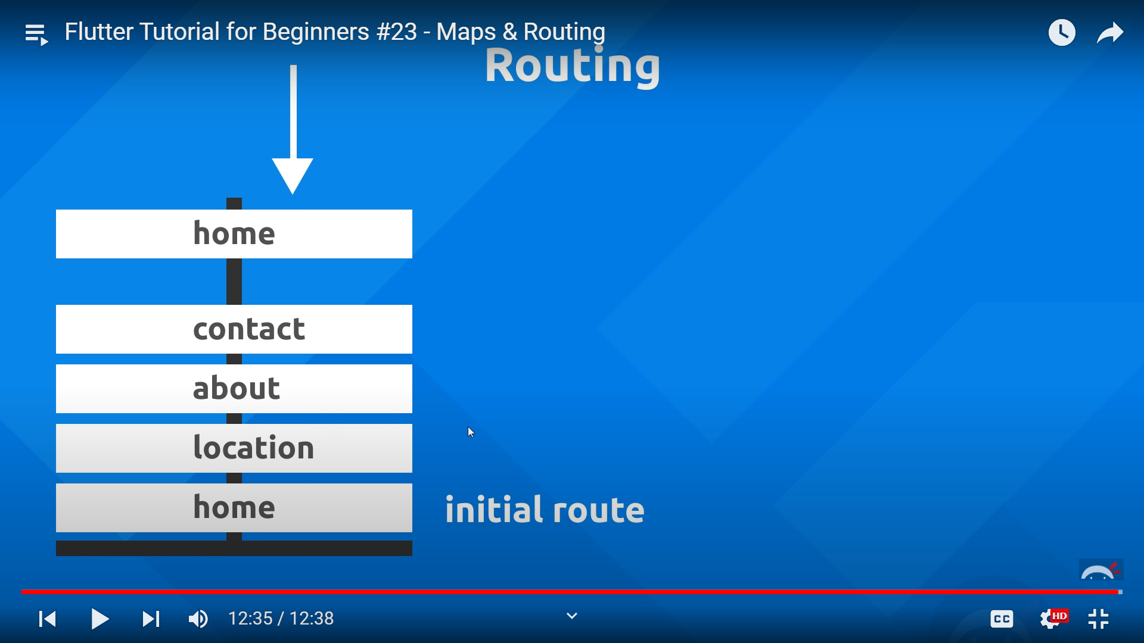

#24 State lifecycle
- addition to stateful widget: initState() and dispose()
- initState() is called whenever the widget is created, best time to set initial values/data and to subscribe to other things (what is subscribe???)
- dispose() is called whenever the widget is removed
- on initState usually theres super.initState() autowritten, it means to call the initState() of whatever the widget inheriting from (at this case, inheriting from StatefulWidget class widget)

#25 Asynchronus code
- Asynchronus code is a code that runs out of code flow so the code is non-blocking for the next statement (where for synchronous/usual code, a code blocks the next statement from run before the said code is finished)’
(illustration is by myself not from yt)
- Imagine we want to make a tea and we need to boil the water, prepare the glass and tea, pour the boiled water, stir (all in order). Imagine ourself as the code flow
- In normal flow (synchronous), we first do (run) the ‘boil water’ task, then we cant do the next task before the present task finished because the current task is blocking us to do so. So, we are forced to wait for ‘boil water’ to finish before we can prepare the glass, etc. Of course, in real life this is kinda dumb because we can leave the water to boil while we prepare the glass and tea and do other things
- In asynchronous code, we do (run) the ‘boil water’ task asynchronously, means that we then can do the next task even the async task hasn’t finished yet. Let say we use a boiler that will ring a ding! When the boiling is finished (a callback function in programming, optional), and let say we need 5 minutes to boil. In this case, what we do is we boil the water, while waiting it to boils we then prepare the glass and tea. As you can see at here we aren’t blocked to do the next things, thanks to async code
- The problem is, when there is another task that actually need a async task result, things can get abrupt. If we continue above case, we eventually will pour the boiling water when it is not boiled yet because we do it instantly without waiting 5 minutes (for the water to boil). In here, we need to wait (await in programming) the boil task to finish BEFORE we do the ‘pour the boiled water task’. Await term is the way to implement synchronousity in our a async codes because at some point we need/require to use the result/callback/anything from the async code before we continue the code flow. So then, the flow is: we boil water, we prepare the glass and tea, we WAIT the boiling water to finish then we pour it to the glass
- back to dart, we play a lot with Future / future keyword when talking about async, basically it holds a result of async task (it has completed and uncompleted state)
- Async is useful when interacting with third party API because it may need some time to do the task. For now, we will use Future.delayed() to simulate the waiting process. Future.delayed() needs two argument first is Duration() (a built in dart class to define time) and a function. E.g. Future.delayed(Duration(seconds: 3), () { print(‘Task Done!’); });
- To make the code flow wait for async code to finish we use await, also the keyword can only be used on asynchronous function. To make that simply put async keyword between parameter pharenteses and before function body e.g. void Task() async { //code }
- A function that marked asynchronous function also behave like async codes when called e.g. let say Foo() is async function then
Foo();
print(‘Hello’);
The print statement will be executed without waiting for what inside Foo() to finish (not blocked by Foo() statement)

#26 Flutter packages
- packages comes from other developer as a helping hand for a complex functionality, save more time to use package rather than code it from scratch
- get flutter packages at https://pub.dev/ then just follow the install instruction (don’t forget to import into the actual dart file)
- for this practice we use http package, basically enable us to do a http request. Then we do a get request to a link that return a dummy JSON data
- Use get() from http to do the req, and give the link as argument (which is wrapped first with Uri.http() ). Then we store it on a Response object (from http to store the get() data). Don’t forget to use await because we interact with third party API and it might need some time to finish
- To get the data we use body property from Response, but the data is still in JSON string so still meaningless
- To fetch JSON string into actual data, use jsonDecode() (need to import dart:convert) and store it into a Map
- Now you can print the data

#27 WorldTime API
- so now we will make a request to the actual API for the project, using https://worldtimeapi.org/
- we will request the JSON format of the API (rather than text format)
- there’s a lot of attribute, for now we will only use datetime and utc_offset attributes (to get the data use Map format e.g response[‘datetime’]
- to make it easier to organize, transform the datetime (string) from the request into a DateTime object, use DateTime.parse() to parse the string format into DateTime format.
- for offset (string), the format is (+/-)HH:MM e.g. +01:00, we need to split the string into more meaningful parts, by using substring() e.g datetime.substring(0,3) means we will take the string from position 0 to 2 (0 <= x < 3), so the substring result is +01
- Then for the actual time we need to add the datetime with offset, basically use DateTime’s add() method and pass in a Duration() argument

#28 Custom class WorldTime
- Basically make a separate dart file containing WorldTime functionality for better reusability, like we have did
- As if we make an async function, we need to wrap the return type with Future<> e.g Future<void>, just to mark the function that its return type is type Future (even if we return nothing a.k.a void)

#29 Error Handling
- We need to thinks about possibility of error (even a tiny bit) so that our app doesn’t crash bcs as Flutter said themselves if theres error its highly that the app crash
- one of what usually make app crash is when related to null. Like if do a method/request but error happened make us cant get the value, the variable gonna be a null and when it assigned to something that is not null safety, cascading error will happen resulting in crash
- To handle that we use try and catch statements, it has try block and catch block where catch usually passed an error object made by dart when theres error inside try block (the error usually typed e as in catch(e)
- basically we run our want-to-avoid-error code inside try block, if theres an error happened inside it the code flow altered to from our try block to our catch block. In there you define what u must to do when an error happen in that specific codes inside try block. As we have an error object e, you can print it to know what is the error or do something else
- You can put chunk of your code inside try block all at once OR you can do try catching method part by part. The latter make us have more control over what we need to do in catch if specific error happen (possibly error1, error2 etc)
e.g. try catch statements
try {
//your code
}
catch(e){
print(“error caught: $e”);
//your prevention if error happened
}

#30 Passing route data
- as we learn earlier, if we use Navigator.pushNamed() it actually push a new screen on top previous one. If we keep doing this the app would be laggy
- So we use Navigator.pushReplacementNamed() so it will push on top of previous screen THEN replace the previous screen. No stack made
- as we move from route to route, each screen unable to know what data is on previous screen, so we need to pass data when routing
- to pass data, write it on arguments: property of the routing method, it takes an Object? e.g. Navigator.pushReplacementNamed(context, “/home”, arguments: {data: “dummy”}) at this example we pass in a map when it wants an Object?, we can do that and will be explained soon
- To receive the passed data from routing use ModalRoute.of(context).settings.arguments where the context needed is from build (??? Still don’t know why this one need inside build() context when context before able outside it and both are stateful widget)
- As mentioned earlier the arguments is an Object?, if we pass other than Object? E.g. Map we need to convert it first by using as Map (in this case). Also, use null settings type is non nullable we need to make sure things isn’t null by using null checker !. (so the intellisense wont cry eks di) e.g. ModalRoute.of(context)!.settings.arguments as Map (in this example we use map for data container)

#31 Formatting and showing dates
- we will use another package to format time value to be more readable with intl package, you would alr know how to install package https://pub.dev/packages/intl
- use it in WorldTime, use DateFormat.jm().format(time) to format it to be better looking before storing into time property
- at the video we start layouting the home screen

#32 Spinner / Loader
- again we use a package flutter_spinkit, u know how to install and import https://pub.dev/packages/flutter_spinkit
- simply change the widget on loading.dart instead of Text() we use the widget provided within the package
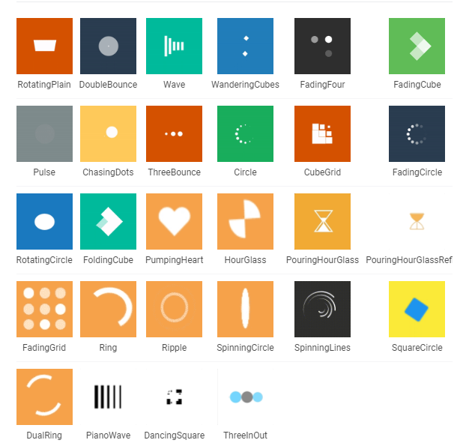
- the widget name is SpinKitType where type is you can choose from these

#33 Ternary operator
- here we will set a bg for our home screen that adapt whether it is in daytime or nightime
- to determine it make a conditional operator, here we use if hour >= 6 and hour <= 18 then it’s a daytime. On the vid it emphasis more on ternary operator tutorial
- there the vid make a quick tutorial how to set a bg image that sits beneath other element and will fit with screen size, it doesn’t rlly tell what is what so u need to read the documentation about box decoration https://api.flutter.dev/flutter/painting/BoxDecoration-class.html
- first we need to wrap everything inside a container, then assign its decoration: with BoxDecoration widget. Inside that, set the image: property with DecorationImage widget. At last, set image: property inside it with image asset (you know how to use AssetImage), then set fit: to BoxFit.cover

#34 List View Builder
- here we will build our choose_location.dart
- we use vid’s assets provided for the worldtime objects
- before that we make a list of available WorldTime for this app
- On location screen theres should be a list of available location we can choose, hence using ListView.builder(). As the name says, it will cycle through a list and do something for each list. its main method is itemBuilder: property that takes a function with context and index as argument. There we will determine what will we do for each list. Other one is itemCount: so the listview can determine its scrollability based on that value
- on itemBuilder, we the return a widget to wrap our each worldtime list. We can use Card then ListTile so it can be tapped (similar with press but there are not just onTap but also onLongPress event). At the ListTile there are title property where we put the content then a leading: property that placed in left before the title. We use the leading to show flags for every location

